Problem definition: We need to provide user with same quality level of visualizer in different screen sizes therefore, we need to construct a responsive design (svg) to scale all content with respect to screen size.

Handled by: Baran nama

Solution:

As can be shown in *Fig. 1*, preserveAspectRatio=“xMaxYMax meet” line aligns the bottom right corner of the viewBox to the bottom right corner of the view port. meet preserves the aspect ratio by scaling the viewBox to fit within the view port as much as possible. We also give width and height to our viewBox taking into account by attribute preserveAspectRatio. We also append a class in order to manipulate further in .css file.

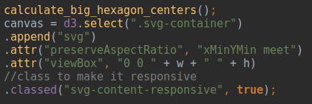  
Figure 1: Responsive design .js file

In *Fig. 2*, the CSS side of the responsive design has been shown. In svg-container, the position is set to relative (parent object) and in svg-content-responsive, the position is set to absolute (child object).It is known absolute positioning inside relative positioning trick. CSS assumes that you want the SVG image to be the full width of the its parent container. The padding-bottom amount represents a ratio between the SVG’s height and width. In this case, the ratio is 1:1, which means that padding-bottom should be %100.

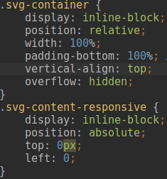

Figure 2: Responsive design .css file

Problem definition: We decided to make a mixture of polygonal and hexagonal design for every each element of SVG illustration. Therefore, a proper creation, positioning and animation of each element should be handled. This section is a bit longer compared to other sections.

Handled by: Baran nama

Solution:

1. Creation and positioning of big left and right hexagon

Hexagons are not the standard objects in d3 native library. Therefore, we need to find a way to create an hexagon and manipulate it (for example positioning) efficiently and properly.

*Fig. 3* shows a basic hexagon creation. We simply uses d3 line generator to create hexagons. However, the problem is that d3 line generator requires line points (6 in this case), but we cannot calculate each point’s position for each creation. We define a calculate_hexagon function which simply takes position of hexagon center that we want to place and radius, and calculates six corner points of a hexagon. Therefore, we can feed our line generator (drawPolygon) and draw our hexagon (or polygon) in desired position. This approach is used for all hexagon and polygon creation (and positioning naturally) among all design. The only changes is done in wrapper functions (calculate_hexagon).These wrapper functions return n points, which are the position of corners of this shape. Therefore, we are also positioning when creating hexagons. The other line of codes for hexagon represent other basic attributes, which simply define styling for this hexagon.

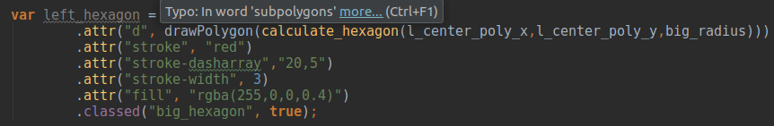  
Figure 3: Big hexagon creation .js file

1. Inner hexagonal structure creation and positioning

Sub-problem definition: We need to create a hexagonal structure around a small center hexagon. However, we do not know how many element should be placed in this structure beforehand. Therefore, we need to create a method that takes the center of central hexagon and number of elements, and it creates this hexagonal structure automatically. This task seems easy at the first glance but it is really tricky mission.

Solution: The first naive approach is to just create outer hexagons in a circular fashion around central hexagon with increasing radius (for each level). However, this approach is not working completely for our design because in each level (in this content, level means a circular shape around central hexagon), the creation circle is not unique. In increasing levels, the number of unique creation circles is increasing.

*Fig. 4* illustrates this situation. In the first level (blue line), we have only one creation circle and we simply create outer hexagons with 60 degree angles around central hexagon. But in the second level, we have two creation circles (green lines). One of them is small and one of them is big. We have to execute two creation operations one for big and one for small creation circle with 60 degree angles. The angle of each element in a creation circle is same but radius of these circles are not the same. In another word, we can calculate the projection of standard radius (yellow straight line) on new radius elements (there is only one new radius in this level: green straight line) and create hexagons by using angle (60 degree) and these radius. If we want to create third level, we need to define three creation circles with three different radius (one of them is standard radius, other two of them are new radius elements).

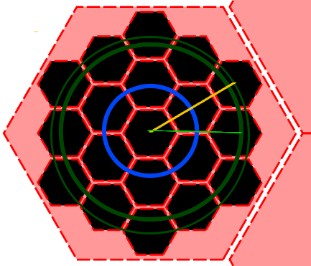



Figure 4: Hexagon structure and creation circles with levels

The psudoalgorithm to tackle this situation is given below.

*1. Calculate the standard radius for this level (yellow straight line)*

*2. Find the angles between standard radius and each new radius elements (each level introduces one additional radius after the first level) and store them.*

*3. Calculate projection of standard radius on new radius planes to find the length of the new radius.*

*4. Create hexagons by using center of central hexagon, all radius elements (standard radius and one additional radius for each level) and angle .*

*5. Store center of each outer hexagon in DOM object using attribute for further use.*

1. Animation of inner hexagonal structure

Sub-problem definition: Our design consists of layers. In the first layer, the most popular game genres is visualized. When user select one or multiple of them and scroll up, structure passes next layer and visualizes the elements in this layer. In layer passing, we need to kind of an animation.

Solution: we design a collapsing-expanding animation system. When user wants to change layer by scrolling up or down, firstly, each outer hexagon in the inner hexagonal structure is collapsing (translating) to central hexagon in this container and expanding to previous places. *Fig. 5* shows general structure of this animation.

  
Figure 5: Collapsing - expanding layer pass animation

The mindset to create this animation is simple. When we place the hexagons, we store each hexagon center in its DOM object as an attribute. Firstly, we find the central hexagon in this container, we calculate the movement vector by simply subtracting from center position of central hexagon to center position of this outer hexagon and translate the position of outer hexagon up to projection of this vector on x and y axis in a certain time (animation time).Because the animation time is the same for each outer hexagon, all outer hexagons are merging on exactly same time on top of center hexagon. Reverse operation is made in order to replace each outer hexagon back to previous place.

1. Event handling for outer hexagons

Sub-problem definition: We have several DOM events by triggering differents event coming from user. We have to define these events and fill these event objects to execute desired behavior.

Solution: The first event is hovering event. When a user hovers an hexagon, the hexagon color is changing. It is very basic manipulation done by using CSS color attribute. Another event in hovering is that a point is touring around hovered hexagon. This is done by sampling from hexagon path (remember that our hexagons is created by lines which are kind of a path) and positioning this point continuously. Note that, the color of point is changing by the status of related hexagon. If it is not added to in graph container, the point is shown in default color. When adding the hexagon to line graph, the point is getting the color of the line related to this hexagon. The last activity in this event is drawing a bigger hover hexagon diagonal to hovered hexagon. We are calculating the vector between hovered hexagon and central hexagon to find an appropriate place to render this hover hexagon. This hexagon is always appeared toward to center hexagon using this vector. Therefore, this hover hexagon is never out of main SVG frame. When hover event is ended, previous state is rolled back (color is changed back to normal, the hovering point disappears).

Another event is selection event. User can select (by clicking related object) one or multiple (depending on layer) objects. When object is selected, the color of selected hexagon is changed. It is done by simple CSS operation. Another important activity in this event is that the selected hexagon data is added to line graph. This process will be explained in line graph section in detail. When the user re-clicks selected object, the color is changed back to its original color and the line related to this hexagon data disappears from graph.

The last event is zooming event. When user selects (by clicking related object) one or multiple (depending on layer) objects and zooms using mouse scroll (scroll up or down) (double clicking is disabled from d3 zoom object to trigger zoom event), the animation (collapsing - expanding) described in previous section occurs and layer changes depending of the direction of scroll (scroll up means go to next layer, scroll down means go to previous layer).The direction of scrolling is determined using the value of d3.event.sourceEvent.deltaY variable. Note that, in the first layer, scroll down event is disabled. Like scroll down, scroll up event is disabled in the last layer. The last activity in this event is destroying the line graph and deselecting all objects in the scene.

1. Creation and placement of other big container polygons

The design also includes another top and bottom big container polygon other than two big container hexagons. As we discussed before, we use d3 line generator to generate any desired polygon. Only requirement for a shape creation is supply of corner points. We wrote the wrapper function to provide those points for line generator to place the shape (hexagon) in desired position. Note that any position calculation for any object including this one were not made as hard-coded values. All object position is calculated by using padding, margin and parent size attributes which means that for any windows size expansion, all object position can be recalculated correctly.

Problem definition: The user can illustrate game statistics and detailed information about an object in the design using related hexagon. However, we need to more complex and ability-to-comparison illustration tools such as line graphs. By using line graph, user can compare statistics of different objects in the same group or from different groups (different containers:steam and twich).

Handled by: Baran nama

Solution: The solution is use of a line graph structure. Native d3 does not included any predefined graph object for visualization, therefore we need to construct our graph structure. *Fig. 6* shows the adding and removing a new line to the graph.

  
Figure 6: General execution of graph structure

When user clicks an hexagon, the related method for handling graph structure first checks an empty place for this data to visualize in line graph. If all slots are full (the limit is 3, empirically set), the user cannot add a new line to graph. If there is an empty slot, the slot is given to this data to represent in a line. Each slot has predefined color in .css file so when the slot is assigned to a selected hexagon, the related data is represented in graph with this color. When user deselects a hexagon, the line and related value placeholder in up-right container are removed and the slot is made free.

As can be seen in Fig. 6, when user hovers a point in graph, the other points have same x value are also hovered with a circle colored in related slot. Moreover, the values of these points are shown in up-right polygon.

Another interesting property of this graph is that the user can zoom or pan the graph easily. Natively, d3 is not provided a polygonal panning and zooming area to use for our implementation. Therefore, we had to create our solution. Firstly, we created a hidden polygonal area exactly same shape with original container (graph container) and this area was placed on top of the original container. After that, d3 zoom object is binded (.call function) to this hidden area. Therefore, the user can zoom and pan the graph, however the problem is that graph is rendered out of related container. So that, we need to clip this visible area of the graph by the shape of graph container. On the top of the layer, a hidden d3 clipping plane that has exactly same shape with graph container was added in order to clip visible area of the graph. It is important to note that, this clipping area is not emitting the zoomming and panning event, so that zoom and pan layer can emit these events. In final, we were able to provide a zoomable and pannable graph area for user.

All of the manipulation is done using native d3 objects. For drawing the graph, d3 axis and scale elements are used in order to draw x and multiple y axis, and properly scale data for these axis. For drawing graph line, d3 line generator and enter event is used. For showing the values in up-right polygon, hover event and d3 text element are used.